Please read the program description carefully before completing this form. Don't hesitate to ask us for advice if you need it! Send your completed form, together with your CV and that of your trainer, to dbastien@quebecdanse.org.

Please note: all fields are mandatory.

Any questions? Contact Daniel Bastien, Director, Professional Development, 514 433-3024.

The Regroupement québécois de la danse’s Coup de pouce program is made possible thanks to the financial support of the government of Quebec, through the Intervention-Compétences program administered by Compétence Culture.

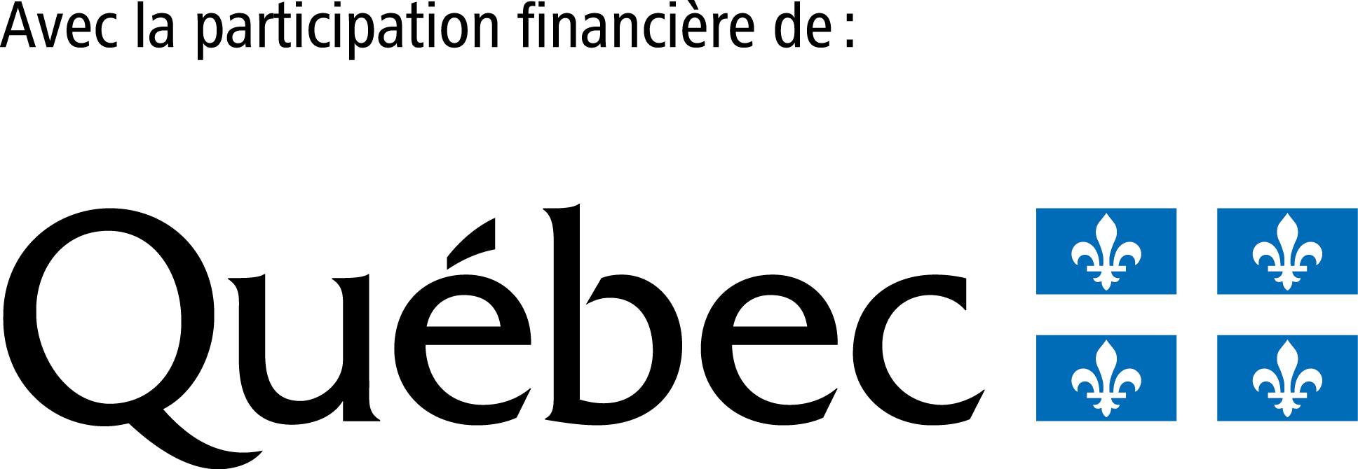

Declaration by applicant (project owner)
I confirm that I have read the terms and conditions of the Coup de pouce program.
Applicant information
Check your program eligibility: quebecdanse.org/en/agenda/coup-de-pouce-custom-trainings/#admissibilite
Identification
Last name: |  |  |  |  | First name:
Profession, job title or function (if you have more than one, please enter the one relevant to your training project):
Phone number: |  |  |  |  | E-mail address:
Address (No./Apt./Street):
City: |  |  |  |  | Province: |  |  |  | Postal code:
Employment status in the cultural sector
Self-employed |  | Full-time employee |  | Part-time employee |  |  | Employment insurance provider
Social assistance provider
If you are employed or self-employed for your own organization: please provide the following information. If you are self-employed and do not have a Quebec Entreprise Number (NEQ), please ignore the fields.
Name of employing organization: |  |  |  |  |  |  | NEQ :
Your position within the organization:
Are you a student?
No | High school, PSD or CEGEP |  |  |  |  |  | Bachelor's, Master's or Doctorate degree
Are you a student or a temporary foreign worker?
Yes | No | If yes, do you hold a valid work permit?
As of today, are you a member of the RQD?
Yes | No
Trainer identification
Consult your trainer to complete this section. Don't forget to send your trainer's curriculum vitae to: dbastien@quebecdanse.org.
Last name: |  |  |  |  |  | First name:
Main professional activity:
Phone number: |  |  |  |  |  | E-mail address:
Address (No./Apt./Street):
City: |  |  |  |  |  | Province: |  |  |  | Postal code:
Trainer's hourly rate or training cost $ |  |  |  |  |  | Is the trainer tax-registered? |  |  |  |  | Yes | No
Training needs
Describe your training needs and the skills you wish to develop. Explain the need for personalized intervention (as opposed to group training, for example). In short, why do you need a Coup de pouce?
Objectives and expected results
Describe the objectives of your project, and the learning and skills you will have acquired or improved by the end of it. What actions or tasks will you be able to perform? What impact will the project have on your practice and employability, or on your ability to secure contracts or increase your income? Indicate concrete, expected results on your employment situation.
Training plan
A Coup de pouce project generally lasts 12 hours: quebecdanse.org/en/agenda/coup-de-pouce-custom-trainings/#duree
Project duration (in hours): |  |  | Start date: |  |  |  |  | End date:
Activities calendar
Consult your trainer to complete this section
List the training activities planned to achieve your objectives. Specify the planned date and estimated duration (in hours) of each activity.
Example :
- November 5, 2023 : budget planning basics (2h)
- etc.

Applicant's financial contribution
Your training can only begin once the RQD has received your payment and your agreement signed by all parties: quebecdanse.org/en/agenda/coup-de-pouce-custom-trainings/#traitement
Select the contribution corresponding to your type of training
Customized individual training or training for a small group of participants (15% of project cost, before tax)
Asynchronous online training (25% of fees, before taxes). You must pay the full registration fee and the RQD will reimburse 75% of this fee (plus taxes, if applicable), upon receipt of supporting documents.

Information from other participants (if applicable)
Check the eligibility of all participants: quebecdanse.org/en/agenda/coup-de-pouce-custom-trainings/#admissibilite
Identification and status of additional participant #1
Last name: |  |  |  | First name:
E-mai address:
Statut d’emploi dans le secteur culturel
Self-employed |  | Full-time employee | Part-time employee |  | Employment insurance provider
Social assistance provider
If you are employed or self-employed for your own organization: please provide the following information. If you are self-employed and do not have a Quebec Entreprise Number (NEQ), please ignore the fields.
Name of employing organization: |  |  |  |  | NEQ :
Your position within the organization:
Are you a student?
No | High school, PSD or CEGEP |  |  |  | Bachelor's, Master's or Doctorate degree
Are you a student or a temporary foreign worker?
Yes | No | If yes, do you hold a valid work permit?
As of today, are you a member of the RQD?
Yes | No
Identification and status of additional participant #2
Last name: |  |  |  | First name:
E-mai address:
Statut d’emploi dans le secteur culturel
Self-employed |  | Full-time employee | Part-time employee |  | Employment insurance provider
Social assistance provider
If you are employed or self-employed for your own organization: please provide the following information. If you are self-employed and do not have a Quebec Entreprise Number (NEQ), please ignore the fields.
Name of employing organization: |  |  |  |  | NEQ :
Your position within the organization:
Are you a student?
No | High school, PSD or CEGEP |  |  |  | Bachelor's, Master's or Doctorate degree
Are you a student or a temporary foreign worker?
Yes | No | If yes, do you hold a valid work permit?
As of today, are you a member of the RQD?
Yes | No
Identification and status of additional participant #3
Last name: |  |  |  | First name:
E-mai address:
Statut d’emploi dans le secteur culturel
Self-employed |  | Full-time employee | Part-time employee |  | Employment insurance provider
Social assistance provider
If you are employed or self-employed for your own organization: please provide the following information. If you are self-employed and do not have a Quebec Entreprise Number (NEQ), please ignore the fields.
Name of employing organization: |  |  |  |  | NEQ :
Your position within the organization:
Are you a student?
No | High school, PSD or CEGEP |  |  |  | Bachelor's, Master's or Doctorate degree
Are you a student or a temporary foreign worker?
Yes | No | If yes, do you hold a valid work permit?
As of today, are you a member of the RQD?
Yes | No
Identification and status of additional participant #4
Last name: |  |  |  | First name:
E-mai address:
Statut d’emploi dans le secteur culturel
Self-employed |  | Full-time employee | Part-time employee |  | Employment insurance provider
Social assistance provider
If you are employed or self-employed for your own organization: please provide the following information. If you are self-employed and do not have a Quebec Entreprise Number (NEQ), please ignore the fields.
Name of employing organization: |  |  |  |  | NEQ :
Your position within the organization:
Are you a student?
No | High school, PSD or CEGEP |  |  |  | Bachelor's, Master's or Doctorate degree
Are you a student or a temporary foreign worker?
Yes | No | If yes, do you hold a valid work permit?
As of today, are you a member of the RQD?
Yes | No

Identification and status of additional participant #5
Last name: |  |  |  | First name:
E-mai address:
Statut d’emploi dans le secteur culturel
Self-employed |  | Full-time employee | Part-time employee |  | Employment insurance provider
Social assistance provider
If you are employed or self-employed for your own organization: please provide the following information. If you are self-employed and do not have a Quebec Entreprise Number (NEQ), please ignore the fields.
Name of employing organization: |  |  |  |  | NEQ :
Your position within the organization:
Are you a student?
No | High school, PSD or CEGEP |  |  |  | Bachelor's, Master's or Doctorate degree
Are you a student or a temporary foreign worker?
Yes | No | If yes, do you hold a valid work permit?
As of today, are you a member of the RQD?
Yes | No
Identification and status of additional participant #6
Last name: |  |  |  | First name:
E-mai address:
Statut d’emploi dans le secteur culturel
Self-employed |  | Full-time employee | Part-time employee |  | Employment insurance provider
Social assistance provider
If you are employed or self-employed for your own organization: please provide the following information. If you are self-employed and do not have a Quebec Entreprise Number (NEQ), please ignore the fields.
Name of employing organization: |  |  |  |  | NEQ :
Your position within the organization:
Are you a student?
No | High school, PSD or CEGEP |  |  |  | Bachelor's, Master's or Doctorate degree
Are you a student or a temporary foreign worker?
Yes | No | If yes, do you hold a valid work permit?
As of today, are you a member of the RQD?
Yes | No

